Rotation is a source of non-electromagnetic impact on
nonequilibrium semiconductor charges and radioactive decay
Вращение – источник неэлектромагнитного воздействия на неравновесные заряды полупроводника и радиоактивный распад
by Miller . A (Мельник И.А.). in conference proceedings, pg. 398 of Торсионные поля и информационные взаимодействия - 2009 Материалы международной научной конференции Электронная версия Хоста, г. Сочи 25-29 августа 2009 Torsion fields and informational
Interactions – 2009. Materials of the International Scientific Conference Electronic version August 25-29, 2009.

Introduction
That rotation can be a source of non-electromagnetic effects,
Ensured for a long time. Almost in the twenties of the last century E. Cartan tied
The density of the angular momentum of rotation withrsion (Torsion) space-time in
framework for the gravity model of the general theory of relativity [1]. Experimental
works N.P. Mishkina essentially appeared the first experienced data,
confirming the existence of some forces of transmitting angular moment [2]. In
The second half of the twentieth century in the Soviet Union has appeared experimental
Studies indicating the generation of non-electromagnetic effects
rotating flywheel gyro and its remote influence at the time
Pulse macroscopic object [3, 4, 5].
Rotation refers to a fundamental movement. To be more accurate, then you can
To say that there are no straightforward movements in the world. Any movement B.
The gravitational field can be characterized by a certain radius of rotation.
Naturally, if this radius is relatively large, and the angle of rotation is insignificant
That described arc (in the limit) will strive for a straight line. Only in this
Cases can be talked about a quasi-polyline and uniform movement.
In the case of rotation - the source of non-electromagnetic effects may be
The moment of forces, and centrifugal (inertial) forces. Currently exist
Multiple theories connecting these forces with such generated
non-electromagnetic fields as a torsion field [6, 28], kogravitational [7],
Massodynamic [8], microlypton [9], chronaal [3, 5], etc. In each case
Based on the theory, possible manifestations of the properties of the listed
Fields. These properties can be revealed experimentally and compared with
Theoretical conclusions.
In recent decades, a number of researchers conducted experiments on
remote effects of rotating objects as at an angular moment
Test object and testimony of various devices [10-18]. Regardless
on how neither the generated fields were determined, when summarizing the results of these
The works were identified the main properties of the generated impact. List
The detected properties of this phenomenon:
1. The generated field transmits the moment of the pulse to the trial macro.
2. The trial object in this field is experiencing a precess.
3. In case of conformity of sizes and masses of trial and leading objects,
The rotating trial object is a source of non-electromagnetic
fields acting in antiphase on the leading object and braking it
rotation. Here there is self-jewelery of both objects.
4. The degree of influence on trial objects is non-linear depending on the speed
Rotation of the master object.
5. The dependence of the shown effects from the direction (clockwise and against
clockwise) rotation. This fact may be associated with education.
Law - and left-sided field.
6. The field in the area of ​​the axis of rotation is inhomogeneously. The degree of exposure
Depends on the location relative to the rotating object.
7. After turning off and stopping the rotation, non-electromagnetic effects
For a long time is in a quasi-stationary condition (phenomenon
Memory).
8. The non-electromagnetic field affects the fluctuation of nonequilibriums
Quantum systems (charges) of radioactive radiation sensors.
9. The field generated by the rotating object changes (mainly reduces)
The rate of decay and fluctuation (dispersion) of the cores of radioactive isotopes.
10. The degree of impact of this field depends on the organization (entropy)
The internal structure of the rotating object. The more organized
The structure, the greater the effect on the trial quantum system.
11. Precession and uneven rotation increase influence on trial
quantum system.
12. The fields of the field is the material from the twisted lavsanov and
Polyethylene threads. Moreover, the material from the right-hand thread is more
degrees absorbs the field when the object is rotated clockwise (view from
Top, material between the object of rotation and trial object). AND,
On the contrary, when rotating counterclockwise to absorb impact
It is necessary to use the thread of the left-sided twist.

Thus, the listed properties of non-electromagnetic effects
generated by a rotating object allow you to tie this field not only with
power component (momentary transmission of momentum), but also with information
exposure (transferring entropy and impact on it in a trial object).
Consider the results of some experimental studies obtained as a result of the remote effect of rotating masses on nonequilibrium quantum
Semiconductor spectrometry systems.
Instruments and equipment experiments
In the late eighties of the last century, using semiconductor gamma spectrometry, in a multi-element neutron activation analysis by the author
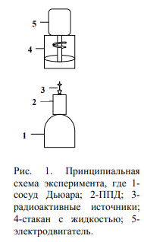
The effect of reducing the readings of the activity of the isotopic source of gammakvants in the presence of a rotating liquid [19] is noted [19]. Subsequent experiments
(Already in our century) fully confirmed the impact of rotation on the decay of the kernel.
[figure annotation: Rice. 1. In principal Experiment scheme, where 1-
Dewar vessel; 2-PPD; 3-radioactive sources; 4-cup with liquid; 5- Electric motor. ]

As measuring equipment was used
semiconductor, GE (LI) -dector (DGDK-63B);
preamplifier (Pug-2K); amplifier (Bui-3K) and
Analyzer (AMA-02F1). Semiconductor
detector, source of gamma radiation and rotating
Rotor shaft are located on one vertical axis
(Fig. 1). In various experiments were used
Electric motors as an asynchronous (type AIR) and
Collector, 150-200 watt, fixed
To the rack. Electric motor rack was attached to
massive steel table (~ 60 kg) and Dewar Vessel
semiconductor detector (PPD) filled
liquid nitrogen (31 kg) was located on soft
platform that prevented the transfer
insignificant vibration from the electric motor to
detector.
Impacts were investigated not only on beta-active
nuclei, but also on alpha radioactive isotopes. V
The quality of the alpha particle sensor was used semiconductor epitaxial
GaAs - GEF detector, with gold contact. 4 × 2 mm detector size
2.
. V
The measuring complex used a pre-amplifier Pug-01,
Wis-04 amplifier and ADC BPA-02 manufactured by the NPC "Aspect".
Engine shaft without nozzles, rotating with angular velocities from 2000 to 8000
rpm in a step of 1000 rpm, both counterclockwise and clockwise (view
From above), was over a radioactive isotopic source. Distances Ot
The radioactive source to the end of the shaft was set by the experimental conditions.
The area of ​​the peak of full absorption (peak) was measured, proportional to the number
Registered gamma quanta (PPD pulses) of this energy and a common integral.
The processing of the analyzed spectrum was conducted by the "Search" program developed by
In Dubna. This program, on calculating the area of ​​the peak, automatically
puts the labels at the point of "inflection" of the distribution of Gauss, which allows you to observe
Identical conditions in the process of calculating the following measurements. Width
The energy resolution of the studied peaks did not exceed 3 keV.
In one hour of measurements, the drift of the center of gravity of the peak in the direction of increasing or lowering
exceeded 0.5 keV.
The measurement of the peak and the integral passed in two modes, 60-100 measurements during operation
Engine and 60-100 measurements after stopping it. "Live" measurement time
was 30-60 s, the time of processing spectrum 35c. Peak area, depending on
Measurement points, was from 4,000 to 10,000 pulses.
In the experiment, the general integral spectrum I was registered, starting with
The first channel of the analyzer scale, i.e. The lower limit of the discriminator was equal
zero (Fig. 2). The figure shows the spectrum of gamma quanta isotope
60.
where possible
Manifestation of noise peaks.

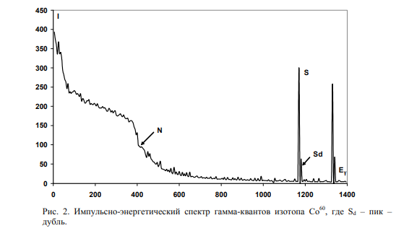
[Pulse-energy spectrum of gamma quanta isotope CO60 where SD is peak - Double.]

In [20], a theoretical analysis of this situation is given and determined that accounting
integral spectrum (the entire energy scale of the analyzer) in the experiment,
avoids the basic unaccounted effects of the electromagnetic field on
statistics. This is due to the fact that the generation of electromagnetic pulses is usually
manifests itself in the first channels of the scale and a significant increase in these peaks in
The turn reduces the peak area of ​​the beneficial signal.
At the input cascade of the pre-amplifier, except for the useful signal with PPD
Internal noise signals formed by the detector reverse current are received.
Input current of the shutter of the field transistor, current leakage current
Connected parallel detector. In addition to internal noise signals for the entrance
The preamplifier can flow the signal generated by external
electromagnetic sources, in this case it is an electric motor and system
Rotation speed control. In turn, the load resistance input
The chains are inversely proportional to the cyclic frequency of the alternating current of the external noise signal. All this leads to fluctuations of permanent load time and
Increase the area of ​​the integral spectrum.
In this case, the noise current is presented in a discrete form in the form of δ-pulses.
In fig. 2, at the beginning of the energy scale (25 keV), visible noise peak,
generated by an external electromagnetic source and increasing common
integral. And due to the fact that the "dead" time of amplitude-digital
TM converter, this is a "dead" time of the prolonged type that peak area
The useful signal will decrease. "Dead" time is processing time
Spectrum, i.e. Analog signal transformation time in digital and, accordingly,
termination of the receipt of the useful signal. We define the integral as n = i - S, where s
- Pick Signal Square (for CO60 isotope
Energy gamma - quanta 1173
CEV and 1332 keV). N value is mostly the amount of the background pulses, Compton
Effect and noise signals. In this case, the difference is of interest.
Peak area in SROT rotation mode and average static peak value
<S_{ST}>. Attitude (S_{ROT} - <S_{ST}>) / Σ_{ST}
S.
Determines the relative fluctuation of the area
Peak, expressed in units of standard deviation σst
S.
. But here it is necessary
take into account the effect of noise signals on the spectrum, so you can enter
Relative value - Q, whose value reflects the fluctuation of peak area
(i.e. core decay speeds) ignited electromagnetic noise
Impulses, i.e.
If | N_{ROT} - <N_{ST}> | <Σst.
N.
then the module is equal to σst
N.
. This condition is statistically
justified, because The value of the module is less than σst
N.
is within the error
Measurements. To assess the proximity of the samples of NROT and NST, you can apply the criterion
Fisher, accordingly, find out what the proportion of external noise impulses (if
They are present in the spectrum) and the degree of their influence on Srot statistics.
The proposed experiment scheme makes it possible to eliminate the effect of trivial
reasons for the results of experiments, due to the emerging research capabilities
behavior of two samples - S and N, as fluctuations in the intensity of decay
affect, first of all, on the form of distribution S and to a much lesser extent on n
(Compton effect). And the own noise of the device and external electromagnetic
Interference will be shown in the integral N. Therefore, the value of Q ~ SROT - <SST> reflects
Changes in the activity of the radioactive source and, accordingly, the degree of influence
non-electromagnetic component generated field generated by excited
Atomic core.
Statistical analysis of experimental results was carried out with a 95% degree
Reliability. When building histograms, the analyzed row was divided into
Intervals with a step H = (xmax - xmin) / (n) 1/2
where N-number of members of a series (sample).

Analysis of the results of the impact on the radioactive decay

Studying the dependence of the magnitude of the average peak area from
Spatial location (along the axis of the electric motor) system
"Source-detector", a change in this value was observed, up to full
Matching distributions when measured in rotation and absence modes
rotation. It can be said that at some points of space the effect of exposure
disappeared. There was a need for experimental confirmation of impact
non-electromagnetic field on a radioactive source, and not on the system
"Source-detector."
The following experiment was carried out: in the absence of rotation mode sequentially
The intensity of photons was measured from two CS137 isotopes
At distances Ot
The surface of the detector is 29 mm and 25 mm. Moreover, the distance was chosen
so that loading to the detector from two sources was the same (in
static mode). At the beginning, 60 measurements of the first source were carried out
("Live" Measurement Time TG = 50C), then the second source (TG = 50C). Research
Repeated when the engine is rotated counterclockwise (Fig. 3). Rotation
Water in steel cup was created uneven (decentned)
rotation of the disk at a speed of 6000 rpm.

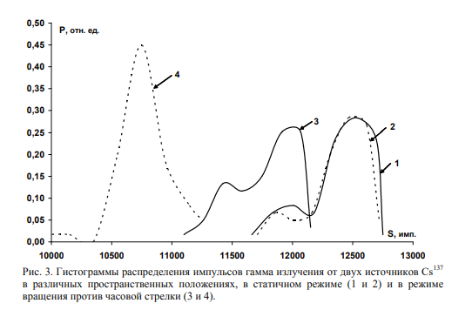
[Histograms of distribution of pulses of gamma radiation from two sources CS137
In various spatial positions, in the static mode (1 and 2) and in mode
Rotation counterclockwise (3 and 4).]

The following results are obtained, for the first source, the average area
Pick in Static Measurement Mode (1) - SST
one
= 12308 imp., Standard deviation
σ = 268 imp., In rotation mode counterclockwise (3) - SPR
one
= 11734 imp.
σ = 297.4 imp.; For the second source (2) - SST
2.
= 12314 imp., Σ = 200.6 imp., (4) -
SPR.
2.
= 10688 imp., Σ = 254.8 IMP. Fisher's coefficients between the distributions of two
Isotopic sources in various measurement modes: FST
1-2 = 0.01 and FPR
1-2 = 425.5 (Q4-
2 = -8.1).

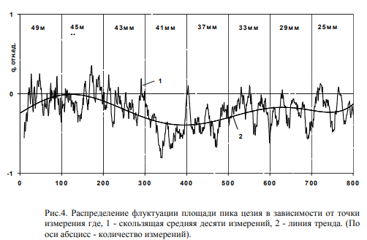

[Distribution of fluctuations of the area of cesium peak, depending on the measurement point where, 1 - moving average of ten dimensions, 2 - Trend line. (Along the abscissa axis - the number of measurements).]

The results of the experiment confirm the presence of the field of influence associated with
The rotation and potential of this field, at each point of space, differ. In all
visibility generated by the rotation field affects the quantum states of the internal
The structures of the excited kernel. When repetition of this experience, results
Confirmed up to the preservation of distributions.
In case of uniform rotation of the rotor of the electric motor, without precession, and with
permanent angular speed in the absence of water in a glass degree of influence on
The decay of atomic nuclei has decreased significantly. Distances from radioactive
Source (CS137.
, standard OSGA type) to the end of the shaft were the following; 25 mm, 29
mm, 33 mm, 37 mm, 41 mm, 43 mm, 45 mm, 49 mm. At rotation speeds of the rotor 7000
rpm and 8000 rpm in comparisons of values ​​of Q values ​​(for CS137), with different
Rotor speed (7000 and 8000 rpm), the following are noted
regularities, firstly, the maximum value <Q8000> = -0.46 acquires
distance 41mm (fig. 4 (on the abscissa axis is given the number of measurements)) at the same time
<Q7000> = -0.48 at a distance of 33mm. Secondly, at distances 45 and 49 mm effect
The shift is almost absent, but the distribution (histogram) of the area of ​​the peak
acquires the shape of the dupet and the difference between the tops of the histogram
is 500 imp.

Points 41 mm. In this case, the difference of vertices of the duplet distribution Q
49.
equal to 1.08.
rem. Statistical analysis of the integral sample showed the following result <NST>
≈ <nrot>, which indicates the lack of noise effects on the spectrometer indication.
When comparing the results of experiments with uneven rotation of water and
uniform rotation of the rotor of the electric motor, where the relative value of two
measurements q4-2 / ​​q7000 = 16.8 can be an indicator of increasing degree
The effects associated with uneven rotation.
In our case, the impact was carried out not only on beta-active isotopes, but also on
Alpha decay. In the Siberian Physico-Technical Institute, based on
Semiconductor detector of the registering alpha - particles were held
Independent (test) Experiments on remote effects
Rotating fluid on a mixture mix of am241
and PU239.
. Measured Pick Square
impulse-energy spectrum of alpha - particles, energy 5485.6 keV (AM241) and
5155 keV (PU239). Engine shaft with a nozzle rotating with an angular speed of 8000
rpm counterclockwise (top view), the liquid rotated in the steel cup.

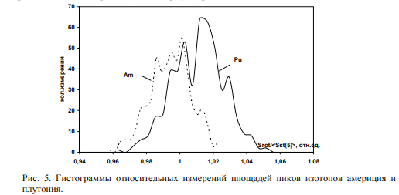

At each distance, the peak measurement took place in two modes, a hundred measurements during engine operation and a hundred dimensions
After it is turned off.
In [15-18], it is shown that after turning off the electric motor is observed
sufficiently long relaxation of the modified distribution of source activity
in every spatial point. In other words, the field generated by rotation,
is in the metastable state more than a week and, at this point
space continues to affect the decay of the nucleus, which, in turn,
leads to a changed distribution of sampling of pulses (from the usual
Poisson distribution, to multi-track distribution with increasing
dispersion). Therefore, statistical analysis must be carried out in comparison with
The first sample obtained before the first measurement in rotation mode. In our
case is possible because The radioactive source is rigid to the detector.
Consequently, the indication of the intensity at each measurement point should not
change (in the absence of impact on an excited kernel).
Building a histogram of the totality of all relative samples SROT / <SST>
convincingly showed that rotation affects the alpha decay of the atomic nucleus,
And the distribution of alpha particles becomes multiplet and intensity
America falls, and Plutonium isotope increases (Fig. 5). Single-factor
Dispersion analysis of these distributions determined the Fisher coefficient F = 98,
With a critical value FK = 3.8.
Statistical analysis of the results obtained revealed; First, rotation
The fluid remotely affects the rate of decay of the excited nuclei, voctern, the magnitude of the decay changes and dispersion depends on the distance
relative to the rotating object and, thirdly, the intensity of the peak AM241
decreased, and the intensity of the peak PU239
increased in rotation mode,
relative to the static measurement mode. Checking statistical hypotheses
It was carried out according to certain values ​​of Student and Fisher's criteria.
Using the phenomenon of quantum nonlocality (confusing quantum states
an ensemble), can be impact on one radioactive source, and
Measure the rate of decay of another source of previously representing one structure.
In the experiment under consideration, the impact on the zn65 isotope was investigated
and
Registering another of the same isotope with the energy of gamma quanta 1115 keV [21].
The essence of the experiment is concluded in the following arguments: first, when
the formation of molecular bonds of zinc salts zinc atoms also join
interaction with each other. Electronic shell atom interacting with
the core, in turn, take into account with the shells of other atoms, which
and leads to confusing certain nuclear states of various quantum
Systems [22]. Relocial correlations between excited nuclei are formed
zinc. Consequently, with a sufficient degree of confusion of excited
quantum states in the case of external influence on these systems leading to
Change of their states (for example, for sample No. 2) in another system (sample number 1)
Quantum states of excited nuclei will also be changed. In this case
Correlation in the velocity of the cores will appear

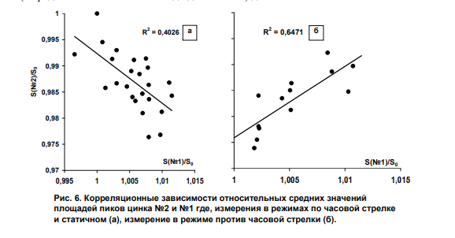

In fig. 6 (a and b) presented the results of correlation analysis of relative
middle peaks (<si> / <s0>) by zinc. Measurements in rotation modes clockwise
the arrow and when the electric motor is turned off (static mode) can be attributed to
one group due to the fact that the static measurement mode goes after the mode
Rotation and, accordingly, this space (down from the bottom of the glass) contains
Residual features and properties of thesis (Fig. 6 (a)). For these modes
Correlation analysis determined the coefficient K = -0.63.
In the case of rotation mode counterclockwise correlation coefficient
The average values ​​of the peaks of zinc samples No. 1 and No. 2 is k = 0.8 (Fig. 6 (b)). Obviously,
Change of correlation sign may be related to the change of exposure orientation
(left or right) when changing the direction of rotation. Statistical analysis
The integral samples showed the following result <NST >> <nrot>, saying about
The lack of noise effects on the spectrometer indication.

Thus, the results of the studies have shown that
The rotating macro is the source of non-electromagnetic effects,
causing both changes in the rate of decay of radioactive nuclei and their
Dispersion.
Analysis of the results of exposure research on
Semiconductor detector
In perennial dimensions of gamma activity of radioactive isotopes
semiconductor spectrometric complex in the hardware spectrum
Gamma quanta were discovered peaks, not identifiable with photon energy
the test isotope, but they have always been located on the energy scale
Approximately 1% above the peak of complete absorption (they were given a name - picdubble, see Fig. 2). It turned out that in experiments with rotating objects, in
depending on the conditions of experience, the average values ​​of the area of ​​peak-duplicate could
change your value several times (Fig. 7). In fig. 7 shows dependencies
The difference between the average values ​​of the peaks of full absorption and peaks-duplicates in the modes
Measurements during rotation and absence of rotation (i.e. ds = | <srot> - <sst> |). It's clear that
The dependence is nonlinear.

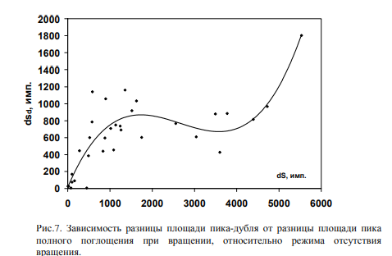
[The dependence of the difference in peak-duplicate area from the difference in the peak area
Complete absorption during rotation relative to the absence mode rotation.]

Further studies have shown that the appearance of peak-dubl is connected with the influence
amplifier. In the case of using another amplifier (with another time characteristic
Achievement of the maximum amplitude (T)) Peak-Doubl disappeared.
Significant peak-duplicity sensitivity from changes in conditions and geometry
measurements in the rotational experiments served as an incentive to
Understand the physical sense of the formation of this peak.

The kinetics of nonequilibrium charges during photoeffect in semiconductors in detail
Studied in [23]. Here it is shown that in the forbidden semiconductor zone there is
Levels of temporary recombination of drifting charges, so on. Slip zone. V
turn, in the semiconductor device, when forming an amplitude of the signal
at the output of the amplifier, the sticking process may be determining, and
The resulting impulse will represent the superposition of two signals -
drifting nonequilibrium charges and temporarily recombined in the zone
adhesion [24]. In this case, the likelihood of the resulting signal appears
(peak-dubl) affect the ratio of such temporary parameters as time picking
charges (TCOB) at the pre-amplifier input condenser and time
Holding in the sticking zone.
It is also known that defects affect the temporary characteristics of the detector
The crystal structure of the semiconductor and, accordingly, the average time
Holding in the catch of charges TPR = N / [γNP (N-NZ)] depends on the quantity
defects n, concentration of charges in nz sticking traps and constant
recombination γ. In this case, NP is the density of free hole states.
"Led" to the level of traps depends on the depth of the hole demarcation
Level of traps [23]. The position of this level is determined by the same
The probability of thermal cast and the probability of recombination.
If the time to achieve the maximum amplitude amplitude amplitude amplitude
T ≠ TCOB, then with TPR <(T - TCOB) of the amplitude component of the impulse, due to the emission
early captured media, increase the output amplitude by ~ 1% (appears
peak double). With TPR≥ (T - TCOB), the output amplitude will correspond to the amplitude
Pick of absorption. In this case, the amplitude of the pulse temporarily recombined
signals will not be registered with equipment, since its value is less than the level
discrimination. If (T - TCOB) << TPR, then peak-double in the hardware spectrum is not
It is implemented (this is possible and with a significant decrease in the achievement time.
Maximum amplitude amplitude amplifier).
Thus, the probability of the appearance of a peak-dupal will depend on the relationship
mean values ​​T, TCOB and TPR, and if attitude
(T - TCOB) / TPR ~ 1, (2)
That sensor sensitivity to remote effects of rotating objects
It will be maximum. Consequently, changes in the time of picking up and time
Holding in the pricking zone of nonequilibrium semiconductor charges (i.e.
energy change) change the average size of the peak-dubl area, which
Accordingly, it leads to a change in the average value of the full absorption peak.
Let us give the following example of simultaneous measurement
137cs I.
60Co in static
Mode (ST) and rotation modes clockwise (PO) and counterclockwise (PR) arrows.
It was carried out at a hundred dimensions in one geometry. When measuring isotopes
137Cs.
(Energy of gamma quantum 661.6 keV) may appear another peak from the average
Energy 669.6 keV. Moreover, frequency

Its appearance V in the sample is different for different modes and measurement geometry.
This is a SD peak. Simultaneously with cesium, peaks were measured
60Co energy 1173 keV and
1332 CEV and respectively, the area of peaks-duplicates, energy of 1183 keV and 1343 keV.
The average area of peak-dubl, taking into account the frequency of appearance in the sample of instrumentation
The spectra is determined by the sd = SDV / 100 formula. The results of experiments are listed in
Table 1.

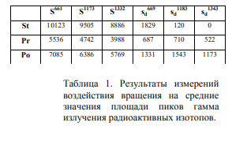
Thus, a decrease in time
Collecting and retaining time in the zone
Adhesive semiconductor charges
Increase the likelihood of appearance
Pick-dub. Changes statistical
Pick-dubl area distributions in
depending on the experimental conditions with
The rotation is confirmed by fact
remote effect of rotation on
Nonequilibrium quantum systems. Using the ratio (2) in
photo-linking semiconductor devices, the opportunity appears
Build a highly sensitive frequency phase sensor
non-electromagnetic field.
Conclusion
Experts - experimenters in the field of physics of the atomic nucleus with distrust and
Skepticism belongs to the results obtained. Extremely difficult, within
traditional concepts, recognize the fact of remote impact of rotation
Macro belt on the rate of decay of excited atomic nuclei. Even agreeing to S.
possible generation of the non-electromagnetic field, the question arises about the constant
the interaction of this field and processes in the excited nuclei leading to
Change of permanent decay.
Recognizing the very fact of availability, and relying on the detected properties of this field
You can make a number of assumptions and hypotheses that allow for a formal level
Note possible approaches to solving questions issued.
Based on the analysis of the listed properties of this field, you can allocate two
basic qualities: information and power transmitting the moment of forces and
orient vector moments of trial objects; information,
transmitting entropy (organization) and affecting information
Entropy of the surrounding space. Moreover, the informational force field
spreads in space with a finite speed, and the information
Impact manifests instantly. It is possible that the rotation is simultaneously
The source of two types of influences.
From the point of view of the synergistic approach, the ensemble of excited atomic nuclei
represents a nonlinear structure in the mode with exacerbation [25]. State
open structure in this mode is extremely sensitive to microflouts
external environment.

Microfluorinational "boiling", then modulated (polarized on the back)
non-electromagnetic field fluctuations of quantum vessels of vacuum in its
queue modulate the magnitude of the fluctuation of the potential energy of the kernel,
Accordingly, the fluctuation, and the constant decay of the excited nuclei.
Another explanation can serve as a hypothesis of generating a rotating object.
non-electromagnetic field with a cruel, orienting vectors of the singering samples
Systems [26]. In this case, the precession of the spins of the slaborotivistic
particles in the external field of twist, as well as the splitting of energy levels in
Particle spectrum. These processes lead to a change in the energy of quantum objects.
Naturally, if in the registered device, or in the radioactive source
Effects are manifested, they can lead to the formation of doublet and
other phenomena in the distribution of the flow of registered particles.
According to the representation of A.N. Kozyrov, etc., the pace (course) of the time organized
Systems depends on entropy streams of surrounding systems and from rotating
Objects affecting the pseudoctor value of the course of time [3, 27]. Turn
time (according to the speed of processes) of the surrounding space of the trial
quantum system may change, which will lead to a change in the internal
The energy of the system itself.
Apparently, all three processes in the system with rotation can occur
At the same time, but for each quantum object the degree of their influence is different. V
Conclusion It should be noted that the listed properties of the studied
impacts based on experimental results, pushing the idea of
The emergence of the integration of various ideas in the construction of theoretical
Models of generated impact.

Literature
1. Cartan E. Comptes Rendus. Akad. SCI., Paris, 1922, v. 174, p.593.
2. Myshkin N.P. The movement of the body located in the flow of radiant energy. //
The magazine of the Russian Physico-Chemical Society, 1906, lied. 3, p. 149.
3. Kozyrev N.A. Selected Works. // L.: Publishing House of the University of Leningrad
1991, 447 p.
4. Fearing K.N. et al. Evaluation of the possibility of using gravitational
Waves for communication purposes. Report on Nir. - M., 1966, p. 17.
5. Weinik A.I. Thermodynamics of real processes // MN: "Woven I Tahnik",
1991. 576 p.
6. Akimov A.E. Heuristic discussion of the problem of new long-range problems.
EGS - Concepts // Preprint ISTC VENT № 7A, M., 1991, p. 63.
7. Efimenko OD Retardics and gravity. // Search for mathematical
Laws of the Universe: Physical Ideas, Approaches, Concepts / Ed. M.
M. Lavrentiev. - Novosibirsk: Publishing House, 2002, p. 25-47.
8. Samokhvalov V.N. Experimental study of Massodynamic
interactions of rotating disks, 2008.
http://www.sciteclibrary.ru/rus/catalog/pages/9038.html/t_blank.

9. Okatrin A.F. Microclusters and ultralight particles. - Reports of the USSR Academy of Sciences,
1989, T.304, Isk.4, p.866 - 869.
10.Samokholov V.N. Gravitational radiation and gravity interaction
with high-speed rotation of small unbalanced masses,
2008.Http: //www.sciteclibrary.ru/rus/catalog/pages/9368.html
11.Padeneluga V.A., Schnol S.E. Experimental effects of influence
Fast rotating massive body on the shape of distribution functions
Alfa-decay speed fluctuations amplitudes // Hypercomplex numbers in
Geometry and physics 3, 1 (5), 2006, p. 102-114.
12.Poisk experimental studies in the field of spin-torsion
interactions // Ed. V.I. Lune - Tomsk, Sibnitsai, 1995, 143 p. (P. 81-
126).
13.Krasnobryzhev V.G. 500,000 tons of coherent matter // Based on Fizical
Modemodії theorest І practice. - Materiali Vіі iompublic
Scientific_Practive Conference, (20-21 Birch 2008). - Kiev, University
"Ukraine", p. 229-248.
14.Melnik I.A. Experimental studies of the effect of rotating
Liquid on the radiation intensity of radioactive isotope. - News
universities. Physics, 2003, №10, p.56-59. (http://trinitas.ru/rus/002/a0231004.htm).
15.Melnik I.A. Experimental detection of preservation of non-PAUSON
statistical distribution of radiation after turning off the source
indignation. - News of universities. Physics, 2004, №2, p.15-18.
16.Melnik I.A. Experimental detection of the effect of rotation on
Statistical distribution of the instrumental spectrum of gamma radiation
Isotopes. - News of universities. Physics, 2004, №5, p.19-26.
17.Melnik I.A. Studies of the electric motor on statistical
Fluctuations of radioactive decay. - News of universities. Physics, 2006, №4, p.32-
38. http://www.chronos.msu.ru/rreports/melnik_issledovanie.pdf.
18. Melnik I.A. Radioactive decay response on remote impact
rotating objects. // Comm. Tr. VI Siberian interdisciplinary
Conferences on mathematical problems of space-time physics
complex systems. Novosibirsk, July 15-20, 2007 - Novosibirsk, Institute
Mathematics SB RAS, 2008. P. 191 - 209.
http://www.quantmagic.narod.ru/volumes/vol432007/p3132.html
19. Melnik I.A. // Deposited in Vinity 5.02.92, N1032-MG92, vol. 4, p. 70.
20.Melnik I.A. Remote Influence Of Rotating Objects On Semiconductor Gamma-Ray
Detector - New Energy Technologies, 2005, №1, p.58-69.
21. Melnik I.A. Detection of radioactive decay speed correlations
Elements in experiments with rotating liquid // Quantum magic, volume 5, vol.
3, 2008, p. 3123-3130.
(http://quantmagic.narod.ru/volumes/vol532008/p3123.pdf)
22.Bargatin I.V., Grishanin B.A., Podkov V.N. Tangled quantum states
Atomic systems. - UFN, 2001, t.171, №6, p.625-647.
23. Rumkin S.M., photoelectric phenomena in semiconductors. // M.,
Fizmatgiz, 1963, 220 s.
24.Erememin V.K., Strokin N.B., Tisnek N.I. Influence of adhesion on charge loss
In semiconductor detectors. - Physics of semiconductors, vol. 11, 1974, p.
2224-2227.

25. Knyazeva E.N., Kurdyumov S. P. The foundation of synergetics. Synergistic
Middle. // M., Komkniga, 2005, 240 p.
26.Bagrov V.G., Bubededer I.L., Shapiro I.L. Possible experimental
Manifestations of the field of twist. - Izvestia universities. Physics, 1992, №3, p. 5-12.
27.Eganova I.A. Nature space-time // Novosibirsk, Publishing House of SB RAS,
Branch "Geo", 2005. - 271 p.
28.Ships G.I. The theory of physical vacuum. Theory, experiments and technology.
// M., Science, 1997.

